SUSMILE translation document
Capsule 3.4.7 Source 2

Consumer study: French people's behaviour on online reviews
Customer reviews and overall e-reputation are now strategic issues for companies in all sectors. Indeed, 70% of Internet users use online reviews before visiting an establishment because they want to be sure to make the best choice.
To understand the behaviour of Internet users with regard to customer reviews and their interactions with local establishments, Partoo has joined forces with the independent firm Happydemics for an exclusive study on a panel of 1100 French respondents aged 18 to 64. Here are the results of the survey.
Contents :
- How do consumers read and write reviews on the Internet?
- For which types of companies do consumers place the most importance on reviews?
- What do people look for in customer reviews?
- The most effective methods for collecting reviews
- The preferred means of communication between Internet users and local establishments
- The main trends highlighted in the study

How do consumers read and write reviews on the Internet?
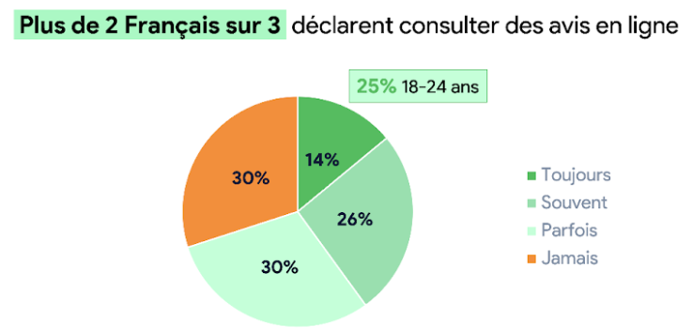
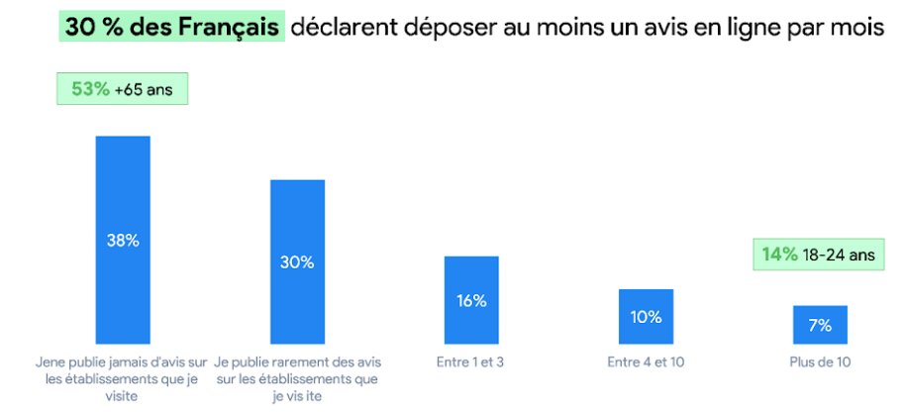
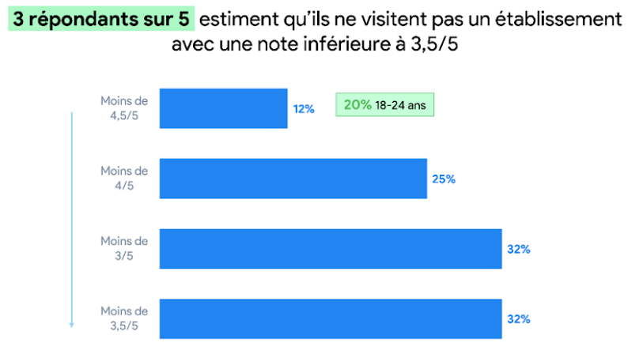
Consumer behaviour trends regarding customer reviews:
- 70% of Internet users read reviews of establishments they intend to visit in the future
- 33% of users post at least 1 review per month for an establishment
- 60% of consumers believe that a rating of less than 3.5/5 is a deterrent to visiting an establishment
For several years now, reading reviews before visiting an establishment has become a habit for Internet users. This trend is even more marked among the youngest respondents (18-24 years old), more than 25% of whom systematically analyse reviews of an establishment before deciding to visit it.
In addition to reading reviews, more and more Internet users are giving their opinion following an experience in an establishment. In addition to reading reviews, young users (18-24 years old) also post a lot of reviews. Indeed, 14% of them write more than 10 reviews per month on local establishments' profiles.
Finally, our study showed that the youngest internet users were also the most demanding in general. Indeed, although 60% of Internet users do not wish to visit establishments with a rating of 3.5/5, 20% of them say that they do not visit businesses with a rating of less than 4.5!

For which types of businesses do consumers place the most importance on reviews?
Overall, reviews are very important for all industries. However, they are most useful for industries such as leisure and medical.
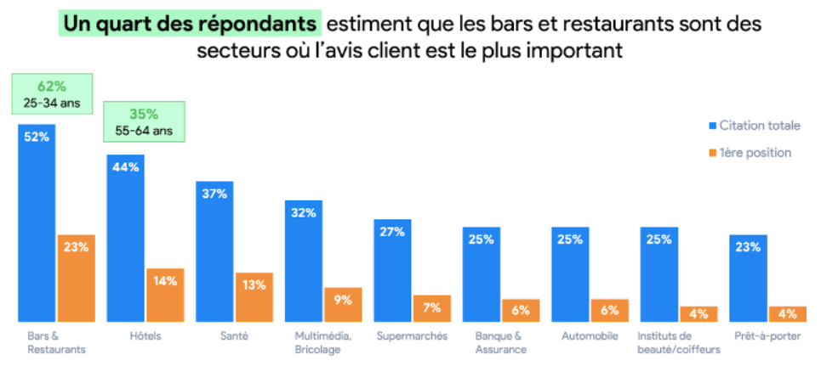
Here are the main activities where reviews play a role in consumer decision-making processes:
- Bars and restaurants: 23% of consumers believe this is the sector where reviews matter most
- Hotels and temporary accommodation (14%)
- Health establishments (13%)
Unsurprisingly, restaurants are the most popular sector for reviews, as consumers want to be sure they are making the right choice from a wide range of establishments. It is the 25-34 year olds who read the most reviews of this type of establishment (62%), whereas older people value reviews for hotels (35% of 55-64 year olds).
Reviews also play an important role for health establishments, especially among 25-34 year olds. This can be explained by the fact that young Internet users do not always have a regular health professional. In order to find a new and trusted practitioner to whom to entrust their medical file, Internet users need to be reassured. Reading feedback from other patients allows them to make a choice between several professionals.

What Internet users look for in customer reviews
For algorithms such as Google's, the frequency, average rating and quality of reviews are decisive in highlighting a local establishment in a search result. But what about Internet users? What do they look at first when they read reviews?
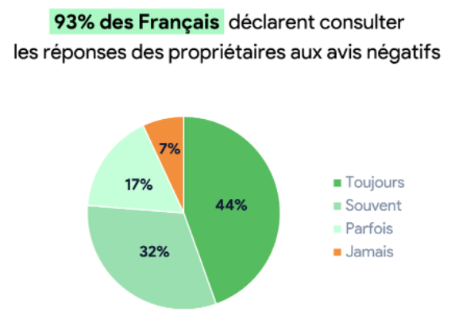
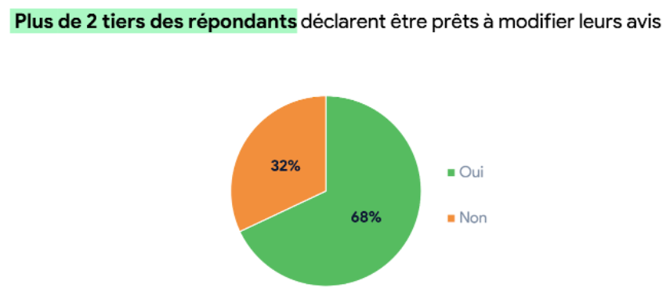
What do web users look for in customer reviews:
- 24% of Internet users look first at recent Internet reviews
- 15% of consumers look at relevant reviews first
- Reading negative reviews is a priority for only 12% of users
- 93% of Internet users consult owners' responses to negative reviews
- 68% of respondents say they are prepared to change their review if the establishment responds appropriately
In general, Internet users want to have as accurate an idea as possible of what their experience in the establishment will be like. This is why recent reviews are the most consulted: 53% of Internet users say they consult reviews left recently by a company's customers. This is true for all age groups combined.
Relevant reviews, i.e. those that are given the most prominence by the algorithms of search engines such as Google and that contain the most keywords, are consulted most frequently by Internet users (41%). This is mainly due to the fact that they appear first when people want to consult reviews.
Even though they are consulted by 39% of Internet users, negative reviews are not the reviews that Internet users read first. We explain these figures by the fact that users are now aware that an establishment cannot please all its customers and that it is therefore normal for it to have negative reviews.
What matters in this case is the response given by the owners to these negative reviews. Indeed, if 93% of users have read the responses of establishments to negative reviews at least once, 45% always read them before deciding whether or not to come to a sales outlet.
In the same vein, consumers are aware that it is difficult to run an establishment. This is why 68% of them say they are lenient and would even be prepared to change their negative review to a positive one if the business manager responded appropriately.

The most effective methods for collecting reviews
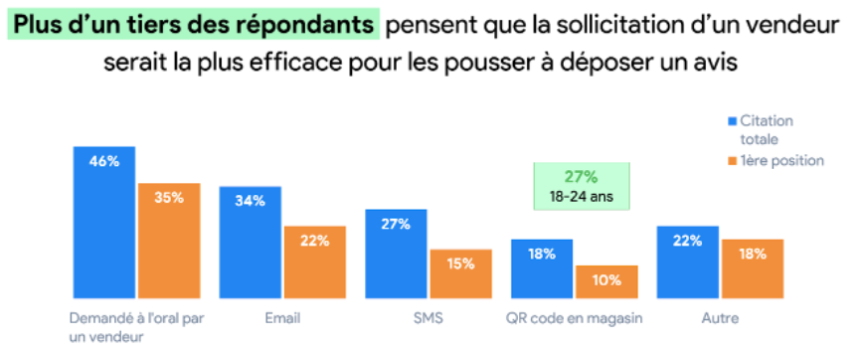

Method of collecting customer reviews:
- 46% of respondents think that soliciting a salesperson is an effective method of collecting reviews
- 27% of consumers mention SMS as a practical technique for collecting reviews
- 18% of respondents think that QR codes are a good way to request reviews
Overall, internet users prefer the least invasive methods of collecting reviews. It is therefore no surprise that 35% of respondents believe that an oral request from a salesperson is the most effective method of collecting feedback. In practice, oral requests alone result in few reviews being submitted, as customers forget as soon as they leave the establishment, or some even do not know how to do so.

This is why it is preferable to combine this oral request with collection methods that facilitate collection, such as SMS or QR codes. These make it possible to go directly to the opinion space of a Google file, for example. This explains why QR codes are widely used to request reviews, especially if the target audience is young.
In addition to collecting reviews, QR codes are now a part of French people's habits. They have even become essential in certain sectors such as the restaurant industry, where players such as Sunday already offer ordering and payment by QR codes. It is easy to imagine that the transposition of these practices to the collection of reviews will be the next step in the digitalisation of an establishment's reputation.

Internet users' preferred means of communication with establishments
To request information on a product, opening times or even to make an appointment, more and more Internet users are contacting businesses before visiting a sales outlet. This trend has increased with the health crisis. They do not want to go to the store if they are not sure to find what they are looking for in the store.
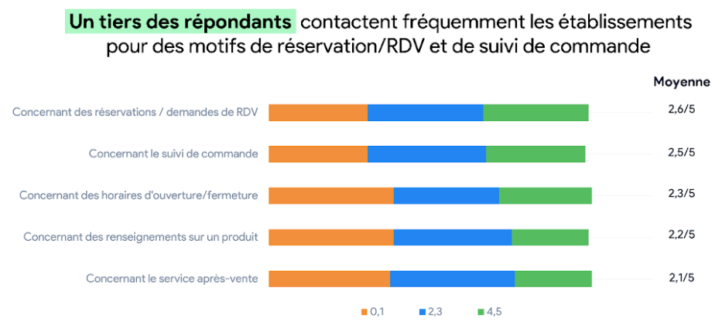
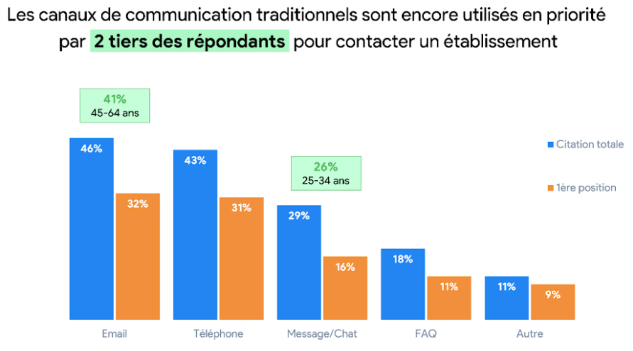
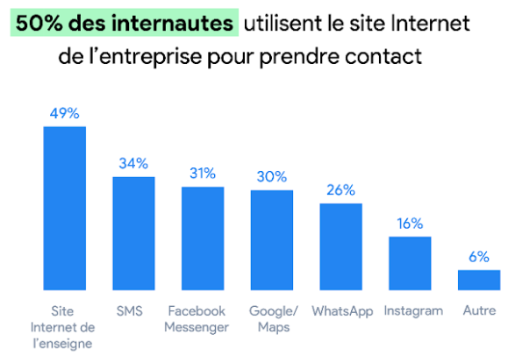
Graphs on main means of communication for consumers local establishments:
- 33% of Internet users contact frequently for booking and appointment purposes
- 31% of respondents contact local establishments for order follow-up
- 32% use email as their main channel of communication with a local business
- The telephone is used by 31% of Internet users to request information
- 49% of instant messenger users say they prefer to use the company's website to talk to them
Generally speaking, Internet users contact local businesses in order to make a purchase. In fact, despite preconceptions, after-sales service is only a reason to contact a quarter of respondents (25%).
Another striking fact: many Internet users still use so-called "traditional" communication channels to contact businesses on the Internet. This is particularly true for the 45-54 year olds, 41% of whom prefer email. However, there has been a strong increase in the use of messages, which were not used much in recent years but which are becoming an essential communication channel, especially among 24-35 year olds. Thus, 26% of young respondents say they communicate mainly by message or chat.
Finally, message users still communicate mostly via chatbots on company websites. SMS as well as instant messaging applications such as Messenger, Google Messages or WhatsApp are used by nearly 30% of Internet users and will certainly grow in importance in the coming years.

To sum up
Customer reviews remain a key lever for businesses as they allow Internet users to form an opinion on the establishments they wish to visit. In addition to reading reviews, many users post reviews at least once a month, with this proportion increasing significantly among the younger respondents.
Contrary to popular belief, negative reviews are not the ones that Internet users read first. However, the response to a negative review remains a determining factor in the choice of an establishment. Internet users are now more indulgent and a large majority are even prepared to change a negative review into a positive one if the establishment gives a constructive response.
Finally, Internet users contact companies mainly to make an appointment or follow up an order. Although traditional communication channels (email and telephone) remain the majority, young people mainly use messages or chat to talk to a sales outlet. These exchanges are mainly done on company websites via chatbots, but instant messaging systems such as Google, Facebook or WhatsApp are also very popular with users.

